Local Events

Oscar Adrian Campos-Soto

Developer

Revision History
Last User to make Changes | Date | Summary of Changes
L. Armstrong | 7/4/2011 | Initial Release

[This section is optional. Revision history may also be recorded as part of version control.]
Table of Contents
Vision Statement 4
Requirements 5
Step #1: Identify Categories of Users 5
Step #2: Create Actor-Goal List 5
Step #3: Identify User Stories 6
Product Backlog 7
[Step #4: Write Use Cases] 8
Sprint #1 12
Review 12
Retrospective 13
Design 14
Coding Standards 15

Vision Statement

For Android users that would like to find local events near them. With Local Events they will be able to create, edit, and view local public and private events. Along with being able to maintain those events. Unlike other apps users will have an easier tool to access local events.
Requirements:

Categories of Users:
Event-Goer – Anyone looking or going to an event.
Event Creators/Admin – The host of an event or event manager.

Actor-Goal List:
Actor | Goal
Event-Goer | Find Events in area
 | Browse list of available events
 | View events information
 | RSVP event if needed
 | Get Notifications when event is starting
Event Creator/Admin | Create an event
 | Create events settings
 | Edit event
 | Edit Settings

Identify User Stories:
- As an Event Creator, I want to be able to create an event that people can attend.
  - Estimated Effort: 10 Story Points.
- As an Event-Goer I want to see local events that I can attend.
  - Estimated Effort: 4 Story points.
- As an Event-Admin I want to be able to edit the event I am hosting so that event-goers are up to date on the event.
  - Estimated Effort: 8 Story points.
- As an Event Creator, I want to be able to make private events, so I can invite only certain people.
  - Estimated Effort: 4 Story points.
- As an Event Creator, I want to be able to make public events, so anyone can attend.
  - Estimated Effort: 4 Story points.
- As an Event-Goer I want to be able to request an invitation to an event.
  - Estimated Effort: 8 Story points.
- As an Event-Admin I want to be able to accept event invite request.
  - Estimated Effort: 8 Story Points.

Product Backlog
The collection of stories makes up your project’s product backlog:

Story ID | Story | Story Points | Priority | Status
S1 | Allow Event Creator to create an event. | 10 | 1
S2 | Allow Event-Goer and creator to view available events. | 4 | 2 | Complete 2/18/18
S3 | Allow Event-Admin to edit the event settings | 4 | 3
S4 | Allow Event Creator to set privacy of event’s. | 8 | 4
S5 | Allow Event-Goer to request an invitation to an event. | 8 | 5
S6 | Allow Event Admin to accept event invite request. | 8 | 6

Sprint #1

Sprint 1 Backlog
Story ID | Story / Task | Estimated  Hours | Actual  Hours
 | Create Database | 2
 | Create user login page. | 4 | 1
S1 | Design main UI and creator UI | 2 | 3
 | Code main UI to creator UI | 3 | 2
 | Test sending to Database | 3
 | Code data input to database | 4
S2 | Display events in main UI | 4 | 4

Sprint #2

Sprint 2 Backlog
Story ID | Story / Task | Estimated  Hours | Actual  Hours
S1 | Create Database | 2
S1 | Test sending to Database | 1
S1 | Code data input to database | 4
S1 | Code user login and storage of login to database | 3

Review
Iteration #1:
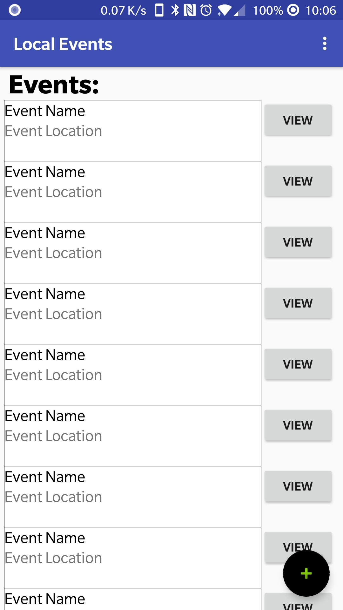
Example of the implementation of event-goer and event creator view of available events. Upon clicking the black and green plus sign the user will be redirected to the event creation activity.

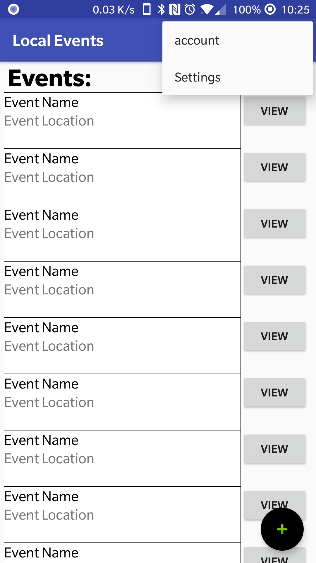
Example of menu options. Where the user can click on account to login.

The login page.
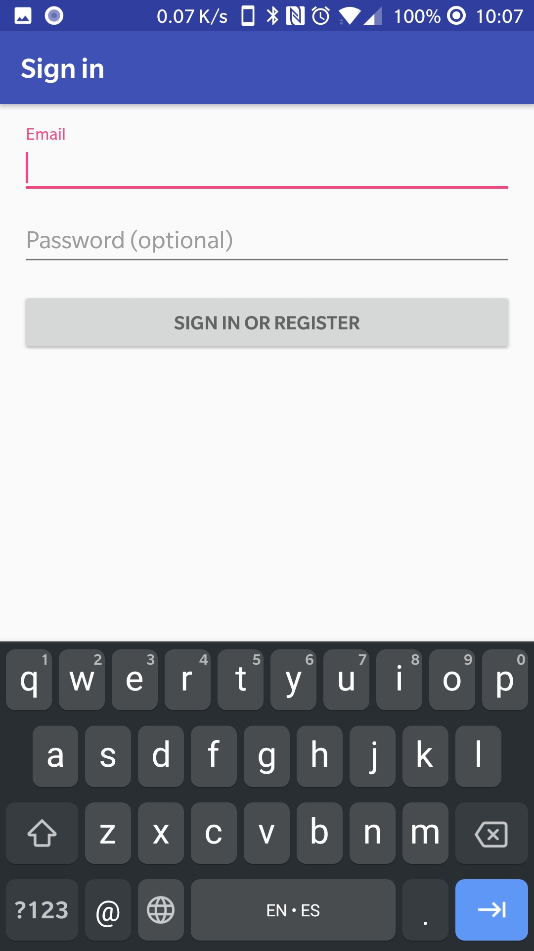

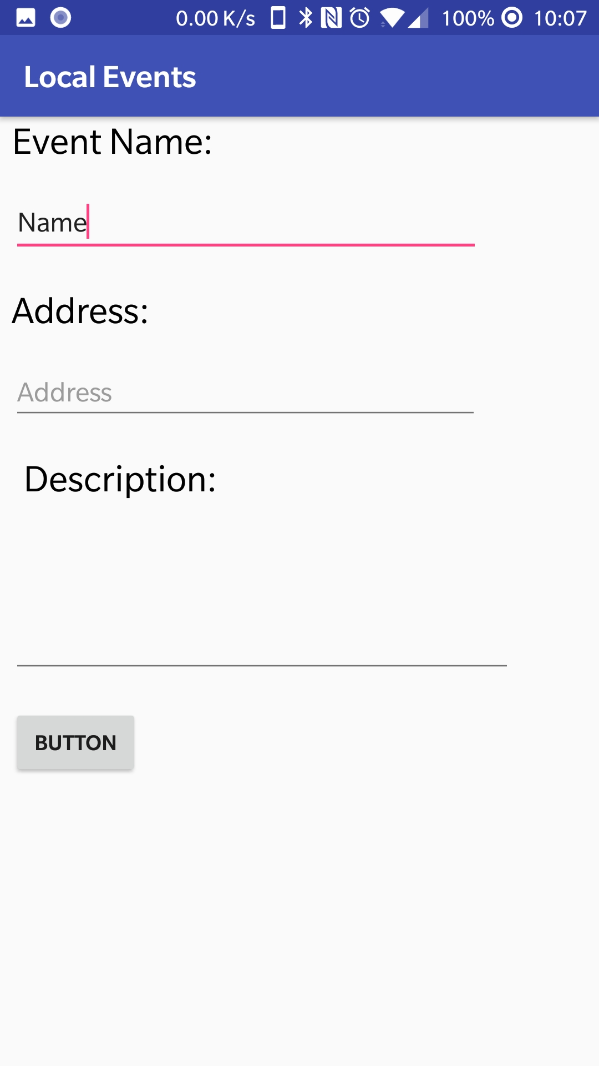
Example of the event creator page.

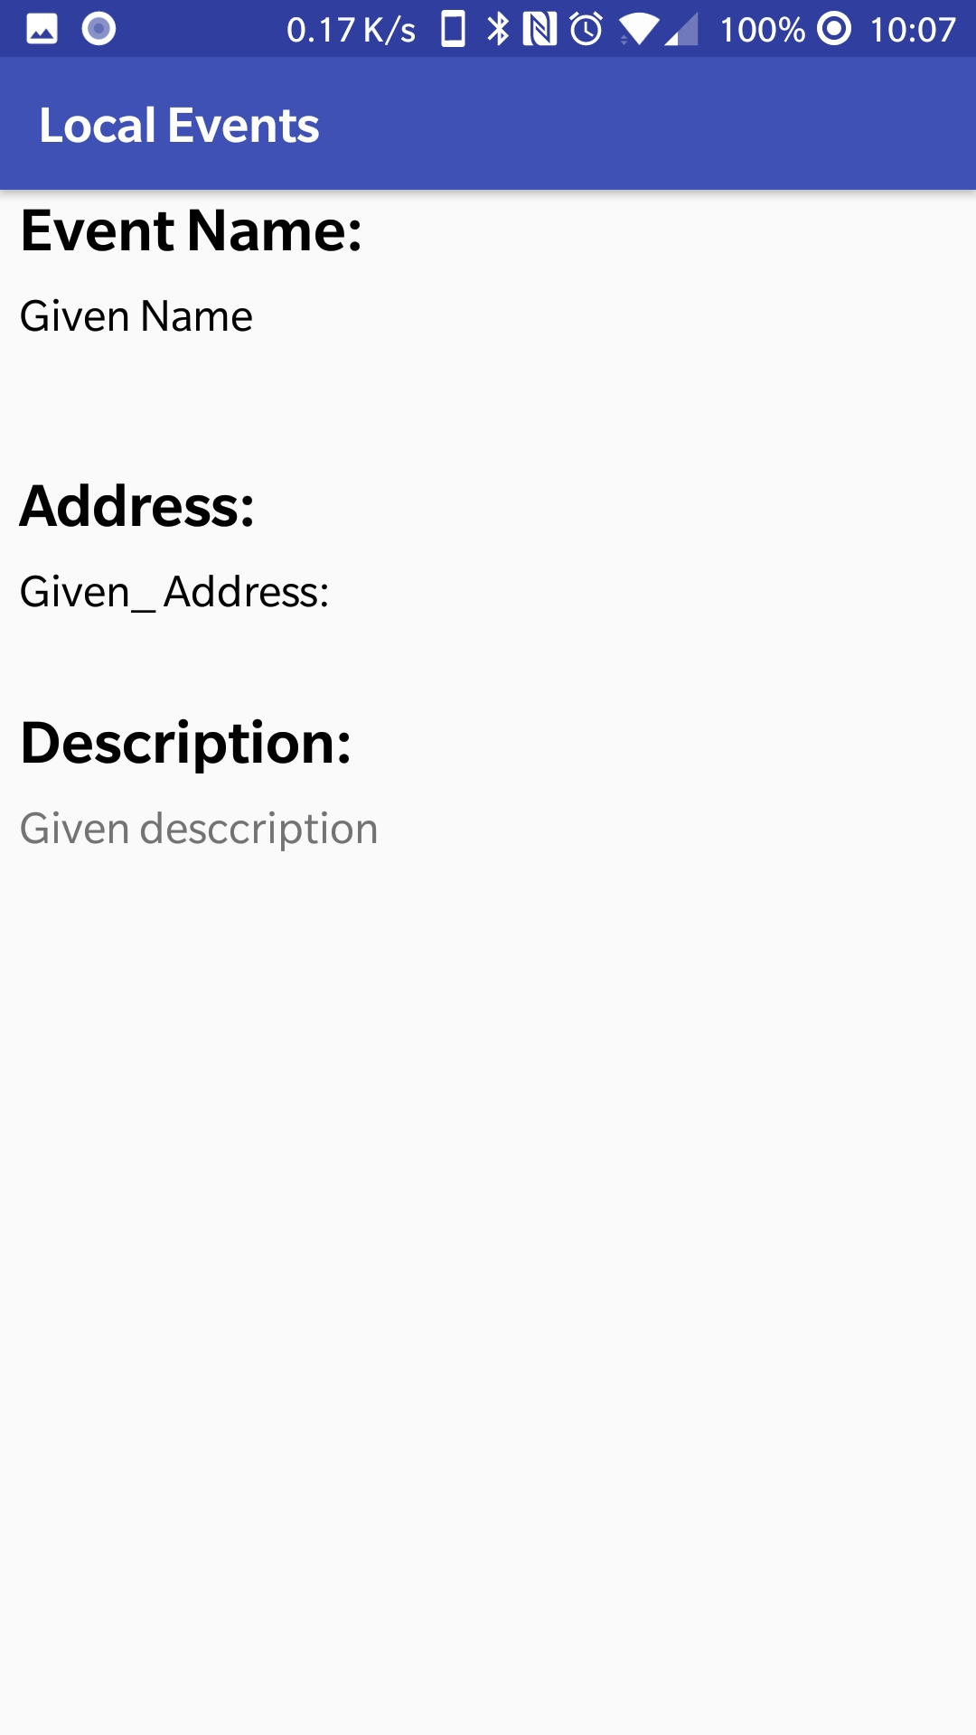
The view page to view the event.

Retrospective:
Iteration #1:
For this iteration, I planned to complete two stories but only part of one was complete. The reason for this was because of underestimating the first task. Creating a database is normally easy but getting the app to communicate with the database is a little more difficult than I anticipated. Therefore, I had to move on to creating the UI for the event goer and creator to view events. Which went well but I could not implement getting data from the database and displaying it. So, I moved on to creating the login page and the implementation of going from the main page to the login page and the create new event page. Finally, I was able to implement the view page, so the creator or event goer can see more details on the event.

Design

Coding Standards
Coding standards improve readability. They make it easier to understand code written by others. Good coding standards also improve reliability.

